**Question 7**

FIRST VIEW

Tables used in the first view:

CUSTOMER

**CREATE TABLE** CUSTOMER  
(  
 **EMAIL VARCHAR**(100) **PRIMARY KEY NOT NULL**,  
 **LASTNAME VARCHAR**(30),  
 **FIRSTNAME VARCHAR**(30) **NOT NULL**,  
 **PASSWORD VARCHAR**(30) **NOT NULL**)

SHOPPINGCART

**CREATE TABLE** SHOPPINGCART  
(  
 CARTID **INT PRIMARY KEY NOT NULL**,  
 **CUSTOMEREMAIL VARCHAR**(40),  
 **ORDERID INT**,  
 **DATECREATED DATE NOT NULL**,  
 **CONSTRAINT** SHOPPINGCART_CUSTOMER_EMAIL_FK **FOREIGN KEY** (**CUSTOMEREMAIL**) **REFERENCES** CUSTOMER (**EMAIL**),  
 **CONSTRAINT** SHOPPINGCART_ORDER_ORDERID_FK **FOREIGN KEY** (**ORDERID**) **REFERENCES ORDER** (**ORDERID**)  
)

ORDER

**CREATE TABLE ORDER**(  
 **ORDERID INT PRIMARY KEY NOT NULL**,  
 **ORDERTYPE VARCHAR**(10) **NOT NULL**,  
 **PAYMENTMETHOD VARCHAR**(20) **NOT NULL**,  
 **ORDERDATE DATE DEFAULT CURRENT DATE NOT NULL**,  
 **FINALAMOUNT FLOAT**(53) **NOT NULL**,  
 CUSTOMEREMAIL **VARCHAR**(100) **NOT NULL**,  
 **HANDLEDATE DATE**,  
 **HANDLER INT**,  
 **SHIPPINGID INT**,  
 **BILLINGID INT**,  
 **CARTID INT**,  
 **TRACKINGNUMBER VARCHAR**(13),  
 **CONSTRAINT** ORDER_CUSTOMER_EMAIL_FK **FOREIGN KEY** (CUSTOMEREMAIL) **REFERENCES** CUSTOMER (**EMAIL**),  
 **CONSTRAINT** ORDER_SHIPPINGADDRESS_SA_ID_FK **FOREIGN KEY** (**SHIPPINGID**) **REFERENCES** SHIPPINGADDRESS (**SA_ID**),  
 **CONSTRAINT** ORDER_BILLINGADDRESS_BA_ID_FK **FOREIGN KEY** (**BILLINGID**) **REFERENCES** BILLINGADDRESS (**BA_ID**),  
 **CONSTRAINT** ORDER_SHOPPINGCART_CARTID_FK **FOREIGN KEY** (**CARTID**) **REFERENCES** SHOPPINGCART (**CARTID**)  
);  
**COMMENT ON COLUMN** ORDER.**ORDERTYPE IS 'PURCHASE or REFUND'**;  
**COMMENT ON COLUMN** ORDER.**PAYMENTMETHOD IS 'VISA/MASTERCARD/AMERICAN EXPRESS/PAYPAL/INTERAC'**;  
**COMMENT ON COLUMN** ORDER.**SHIPPINGID IS 'Shipping Address ID'**;  
**COMMENT ON COLUMN** ORDER.**BILLINGID IS 'Billing Address ID'**;  
**COMMENT ON COLUMN** ORDER.**CARTID IS 'Shopping Cart ID'**

CARTDETAILS

**CREATE TABLE** CARTDETAILS  
(  
 **CARTID INT NOT NULL**,  
 **COLOR VARCHAR**(15) **NOT NULL**,  
 **SIZE VARCHAR**(10) **NOT NULL**,  
 **MODELNAME VARCHAR**(30) **NOT NULL**,  
 **QUANTITY INT DEFAULT** 1 **NOT NULL**,  
 **CONSTRAINT** CARTDETAILS_CARTID_COLOR_SIZE_MODELNAME_PK **PRIMARY KEY** (**CARTID**, **COLOR**, **SIZE**, **MODELNAME**),  
 **CONSTRAINT** CARTDETAILS_SHOPPINGCART_CARTID_FK **FOREIGN KEY** (**CARTID**) **REFERENCES** SHOPPINGCART (**CARTID**),  
 **CONSTRAINT** CARTDETAILS_CLOTHINGUNIT_COLOR_SIZE_MODELNAME_FK **FOREIGN KEY** (**SIZE**) **REFERENCES** CLOTHINGUNIT (**SIZE**)  
)

This view is named “YellowBuyers” and it represents every customer who purchased one or more yellow clothing units. It shows the customers’ full names, the names of the clothing models bought and the dates each customer created his/her shopping cart.

**CREATE VIEW** YellowBuyers (**firstname**, **lastname**, **modelname**, **dateofcartcreation**)  
 **AS SELECT** C.**firstname**, C.**lastname**, D.**modelname**, S.**datecreated  
 FROM** CUSTOMER C, SHOPPINGCART S, CARTDETAILS D, ORDERO  
 **WHERE** C.**email** = S.**customeremail and** S.**CARTID** = D.**CARTID  
 and** D.**CARTID** = O.**CARTID and** O.**ordertype** = **'PURCHASE'  
 and** D.**color** = **'YELLOW'**;

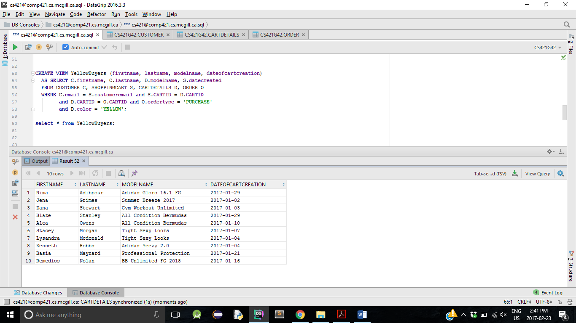

Query: Display the full names of the customers who created their shopping cart after January 10th, 2017

**SELECT FIRSTNAME**,**LASTNAME  
 FROM** YellowBuyers  
 **WHERE dateofcartcreation** > **'2017-01-10'**;

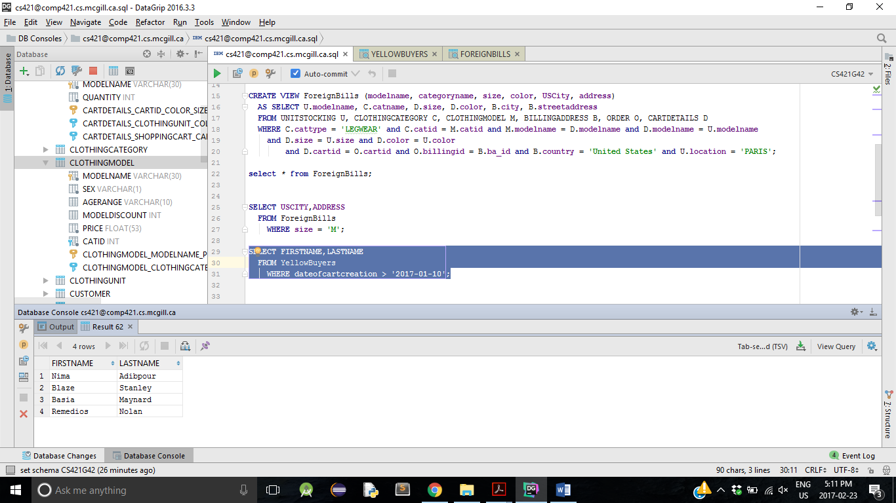

SECOND VIEW

Tables used in the second view:

UNITSTOCKING

**CREATE TABLE** UNITSTOCKING  
(  
 **MODELNAME VARCHAR**(30) **NOT NULL**,  
 **QUANTITYAVAILABLE INT NOT NULL**,  
 **LOCATION VARCHAR**(20) **NOT NULL**,  
 **COLOR VARCHAR**(15) **NOT NULL**,  
 **SIZE VARCHAR**(10) **NOT NULL**,  
 **CONSTRAINT** UNITSTOCKING_COLOR_SIZE_PK **PRIMARY KEY** (**COLOR**, **MODELNAME**, **SIZE**, **LOCATION**),  
 **CONSTRAINT** UNITSTOCKING_WAREHOUSE_LOCATION_FK **FOREIGN KEY** (**LOCATION**) **REFERENCES** WAREHOUSE (**LOCATION**)  
);  
**COMMENT ON COLUMN** UNITSTOCKING.**QUANTITYAVAILABLE IS 'Current Stock'**

CLOTHINGCATEGORY

**CREATE TABLE** CLOTHINGCATEGORY  
(  
 **CATID INT PRIMARY KEY NOT NULL**,  
 **CATNAME VARCHAR**(50) **NOT NULL**,  
 **CATTYPE VARCHAR**(20) **NOT NULL**,  
 **CATEGORYDISCOUNT INT DEFAULT** 0 **NOT NULL**);  
**COMMENT ON COLUMN** CLOTHINGCATEGORY.**CATEGORYDISCOUNT IS 'Displayed as percentage'**

CLOTHINGMODEL

**CREATE TABLE** CLOTHINGMODEL  
(  
 **MODELNAME VARCHAR**(30) **PRIMARY KEY NOT NULL**,  
 **SEX VARCHAR**(1) **NOT NULL**,  
 **AGERANGE VARCHAR**(10),  
 **MODELDISCOUNT INT DEFAULT** 0,  
 **PRICE FLOAT**(53) **NOT NULL**,  
 **CATID INT NOT NULL**,  
 **CONSTRAINT** CLOTHINGMODEL_CLOTHINGCATEGORY_CATID_FK **FOREIGN KEY** (**CATID**) **REFERENCES** CLOTHINGCATEGORY (**CATID**)  
);  
**COMMENT ON COLUMN** CLOTHINGMODEL.**MODELDISCOUNT IS 'Percentage Values'**

BILLINGADDRESS

**CREATE TABLE** BILLINGADDRESS  
(  
 STREETADDRESS **VARCHAR**(50) **NOT NULL**,  
 **CITY VARCHAR**(20) **NOT NULL**,  
 **"Postal/Zip" VARCHAR**(15) **NOT NULL**,  
 **COUNTRY VARCHAR**(15) **NOT NULL**,  
 **BA_ID INT PRIMARY KEY NOT NULL**)

ORDER

Refer to First View

CARTDETAILS

Refer to First View

The view is named “ForeignBills” and it represents all the legwear clothes that were produced in the Paris warehouse but billed at an address in the United States. The view shows the name of the clothing model, its legwear category, the size and color of the model the customer ordered and the address of the customer.

**CREATE VIEW** ForeignBills (**modelname**, **categoryname**, **size**, **color**, **USCity**, **address**)  
 **AS SELECT** U.**modelname**, C.**catname**, D.**size**, D.**color**, B.**city**, B.**streetaddress  
 FROM** UNITSTOCKING U, CLOTHINGCATEGORY **C**, CLOTHINGMODEL M, BILLINGADDRESS B, ORDERO, CARTDETAILS D  
 **WHERE** C.**cattype** = **'LEGWEAR' and** C.**catid** = M.**catid and** M.**modelname** = D.**modelname and** D.**modelname** = U.**modelname  
 and** D.**size** = U.**size and** D.**color** = U.color  
 **and** D.**cartid** = O.**cartid and** O.**billingid** = B.**ba_id and** B.**country** = **'United States' and** U.**location** = **'PARIS'**;

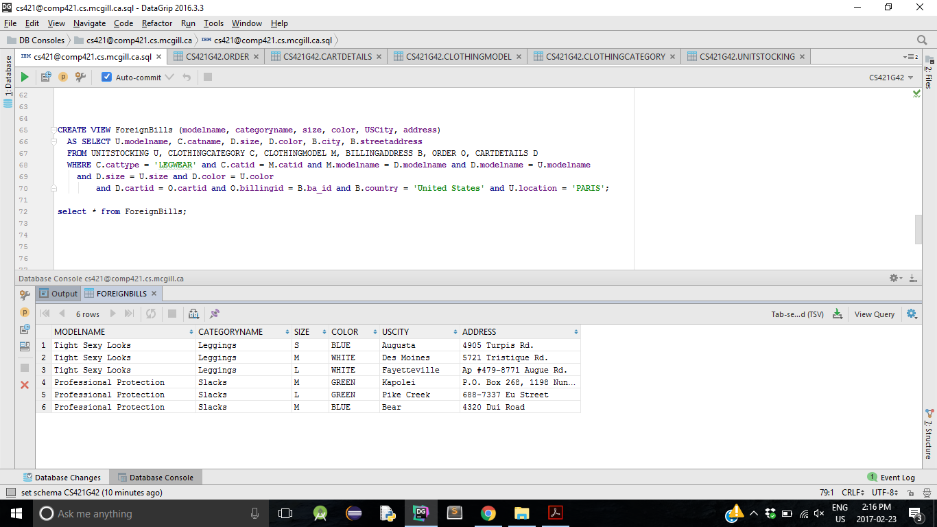

Query: Display the full address of the customers with medium sized legwear clothes.

**SELECT USCITY**,**ADDRESS  
 FROM** ForeignBills  
 **WHERE size** = **'M'**;

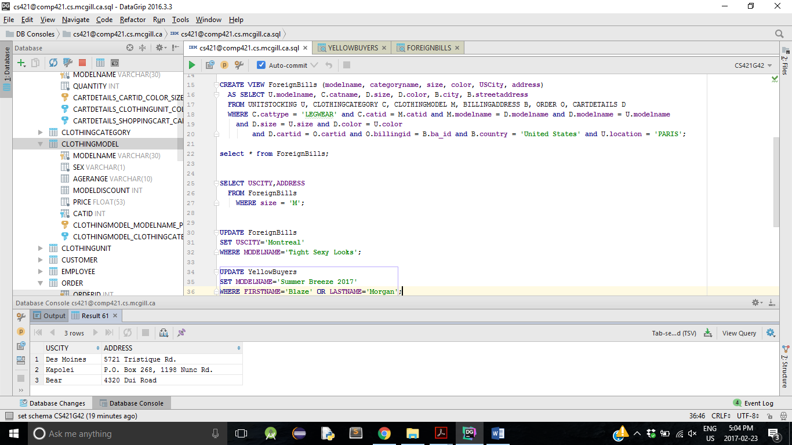

UPDATE STATEMENTS

Let's try running the following SQL UPDATE statement on the view “YellowBuyers”:

**UPDATE** YellowBuyers  
**SET MODELNAME**=**'Summer Breeze 2017'  
WHERE FIRSTNAME**=**'Blaze' OR LASTNAME**=**'Morgan'**;

We expect this to replace the actual clothing models purchased by Blaze Stanley and Stacey Morgan by the model “Summer Breeze 2017”. However, the following message gets displayed once the statement is ran:

“[42807][-150] The target fullselect, view, typed table, materialized query table, range-clustered table, or staging table in the INSERT, DELETE, UPDATE, MERGE, or TRUNCATE statement is a target for which the requested operation is not permitted.. SQLCODE=-150, SQLSTATE=42807, DRIVER=4.7.85”

Now, let’s try running the following SQL UPDATE statement on the view “ForeignBills”:

**UPDATE** ForeignBills  
**SET USCITY**=**'Montreal'  
WHERE MODELNAME**=**'Tight Sexy Looks'**;

We expect this to replace all the actual US city entries where the name of the clothing model is ‘Tight Sexy Looks’ with ‘Montreal’. However, the exact same message as the previous one gets displayed.

None of the two views are updatable!

This makes sense because in order for a view to be updated, the base tables used to create the view also need to be updated. Let’s take for instance the view “YellowBuyers”. The names of the clothing models associated with the names of the customers were obtained by getting the e-mail address of each customer from table “CUSTOMER”, which is also a foreign key in table “SHOPPING CART”. Thus, the id of the shopping cart, which is also a foreign key in table “CARTDETAILS”, can be associated with the name of the clothing model from “CARTDETAILS”. In brief, the information stored in “YellowBuyers” comes from the retrieval of different foreign keys of different tables. Updating the view in this instance would mean updating every entry inside the involved foreign key columns of every base tables. This is a very similar situation with “ForeignBills” since it was generated based on multiple tables.

For DB2 or PostgreSQL to allow updating a view, the view must be defined based on one and only one table. Furthermore, the view must include the primary key of the table based upon which the view was created. Indeed, the view must be able to perform a UPDATE command on itself without affecting any other table.